

Assessment Cover Page
Student Full Name | Maciel Lourdes Cáceres Orozco
Student Number | 2026540
Module Title | Strategic Thinking
Assessment Title | CA1 – Capstone Project Proposal
Lecturer/Supervisor | Taufique Ahmed
Assessment Due Date | 25/10/2026
Date of Submission | 25/10/2026
GitHub Repository | https://github.com/2026540-MacielCaceres/CA-1-Capstone-project-proposal.git
Use of AI Tools
I acknowledge the use of Claude (Anthropic) to support my understanding of the assessment requirements, clarify the business problem, explore the suitability of analytical methods, and identify methodological considerations relevant to the proposed project. The tool was also used to obtain feedback on project structure, feasibility, and potential limitations. I critically reviewed the suggestions and remained responsible for evaluating the evidence, verifying relevant sources, making the final project decisions, and ensuring the accuracy and integrity of the submitted work. The prompts and relevant outputs are documented in the appendix.

Contents
1. Project Title 1
2. Introduction 1
3. Problem Definition 1
4. Aim and Objectives 1
5. Scope 2
6. Methodology 2
7. Data Sources 3
8. Expected Deliverables 3
9. Project Timeline 3
10. Ethical and Legal Considerations 4
References 5
Appendix A: Use of AI 6
A.1 AI Declaration (AI Fluency Framework) 6
A.2 Prompts and outputs 7

1. Project Title
Who Will Buy Again? Predicting Customer Churn and Lifetime Value to Prioritise Retention Spend at a UK Online Retailer

2. Introduction
Online retail has low switching costs: a competitor is always one click away. For e-commerce firms, keeping existing customers is usually cheaper than acquiring new ones, and small gains in retention can raise profits substantially (Reichheld and Sasser, 1990). Yet many firms still spend their marketing budget uniformly, without knowing which customers are about to lapse or how valuable they are. This project proposes a data-driven retention strategy for a UK-based online gift-ware retailer. It treats customer analytics as a source of competitive advantage, turning data the firm already collects into business intelligence that guides decisions (Davenport and Harris, 2007).

3. Problem Definition
The retailer serves around 5,900 identifiable customers, many of them wholesalers, but has no systematic way to detect when a customer is drifting away. Revenue is expected to be concentrated in a minority of accounts, so losing a few high-value customers has a disproportionate impact. Without prediction, retention actions (e.g. discounts) are either applied to everyone, wasting margin on customers who would have returned anyway, or applied too late.
The business problem is therefore: which customers are likely to stop purchasing in the next 90 days, and which of them are worth the cost of retaining? Predictive modelling can rank customers by churn probability, while customer lifetime value (CLV) modelling estimates the revenue at stake. Combining both lets the retailer target the ‘high-value, high-risk’ segment first, where profit-driven churn management creates most value (Verbeke et al., 2012).

4. Aim and Objectives
Aim: To develop and evaluate a predictive analytics solution that identifies customers at risk of churn and estimates their future value, enabling the retailer to prioritise retention spend.
O1 Prepare a clean, customer-level dataset from about 1.07 million transaction lines, documenting every cleaning decision.
O2 Explore purchasing behaviour and segment customers using RFM (recency, frequency, monetary) analysis and K-Means clustering (Chen, Sain and Guo, 2012).
O3 Build and compare churn classifiers (logistic regression baseline, Random Forest, XGBoost) with a time-based validation design, targeting a ROC-AUC of at least 0.75.
O4 Estimate 12-month CLV with probabilistic models (BG/NBD and Gamma-Gamma) (Fader, Hardie and Lee, 2005a; 2005b).
O5 Translate the results into a prioritised retention list and an interactive dashboard for marketing decision-makers.
Hypothesis. H1: a machine-learning model using behavioural features (recency, frequency, monetary value, tenure and returns) predicts 90-day churn significantly better than a simple recency rule; H0: there is no significant difference in ROC-AUC, tested with DeLong’s test (DeLong, DeLong and Clarke-Pearson, 1988). Business hypothesis: targeting the top 20% of customers by expected value-at-risk captures more than half of the revenue at risk.

5. Scope
In scope | Out of scope
UCI Online Retail II dataset transactions (both yearly sheets);  data cleaning, exploratory analysis, RFM segmentation, churn classification, model explainability and probabilistic CLV; and a Python dashboard prototype. | Product recommendation engines and price optimisation  Real-time deployment or production APIs  Live campaign testing (proposed as future A/B testing)  External data (demographics, web clickstream, marketing costs)  Guest transactions without ID in customer-level models

6. Methodology
The project follows CRISP-DM (Chapman et al., 2000) because it starts from business understanding and is iterative, which suits a two-semester project. Figure 1 shows the proposed workflow.
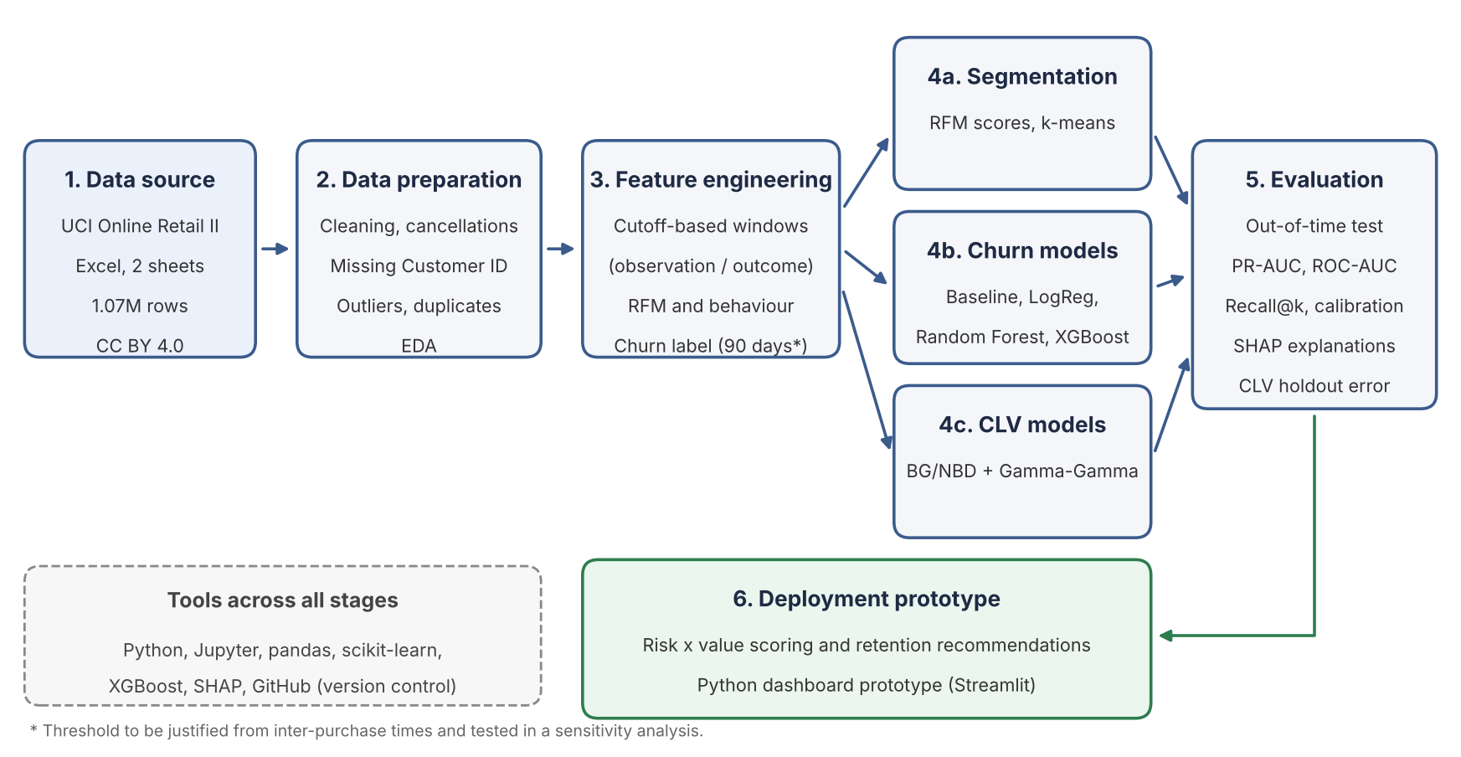
Figure 1. Proposed architecture: data flows from the UCI source through preparation and feature engineering into three modelling streams, a common evaluation stage and a deployment prototype.
Preparation. Transactions without a Customer ID, duplicates and non-product codes (e.g. postage) are removed; cancellations (invoices prefixed ‘C’) are treated as returns. Data are then aggregated to one row per customer with RFM, tenure, basket and returns features.
Churn modelling. A cut-off date splits each customer’s history into an observation window (features) and a 90-day outcome window (label: no purchase = churned). Training uses earlier cut-offs and testing later ones, preventing data leakage. Logistic regression provides an interpretable baseline; Random Forest (Breiman, 2001) and XGBoost (Chen and Guestrin, 2016) capture non-linear effects. Models are compared with ROC-AUC, PR-AUC and recall in the top 20% of scores, which mirrors a limited retention budget. SHAP values explain the drivers of each prediction (Lundberg and Lee, 2017).
CLV. BG/NBD and Gamma-Gamma models suit non-contractual settings, where churn is never explicitly observed.
Open-source tools support reproducibility at no licence cost: Python and Jupyter (pandas, scikit-learn, XGBoost, SHAP) and GitHub for version control.

7. Data Sources
The project uses the Online Retail II dataset from the UCI Machine Learning Repository (Chen, 2012). It contains 1,067,371 invoice lines from a UK-based online gift-ware retailer between 01/12/2009 and 09/12/2011, with eight variables: Invoice, StockCode, Description, Quantity, InvoiceDate, Price, Customer ID and Country. Its transaction-level granularity allows behavioural features and time-based churn labels to be built. Known quality issues (missing Customer IDs, cancellations, negative quantities and outliers) will be handled during preparation.
Permission. The dataset is publicly available under a Creative Commons Attribution 4.0 (CC BY 4.0) licence, which allows sharing and adaptation, including for commercial purposes, provided the source is credited (Creative Commons, no date).

8. Expected Deliverables
By the end of Semester 2 the project is expected to produce: reproducible Jupyter notebooks in the GitHub repository; a cleaned, documented dataset with a data dictionary; an evaluation report comparing churn models and CLV estimates; a ranked risk-and-value customer list with retention recommendations; a Streamlit dashboard prototype; and the final capstone report.

9. Project Timeline
Semester 1 focuses on framing, data understanding and preparation; Semester 2 on modelling, evaluation and delivery (Figure 2).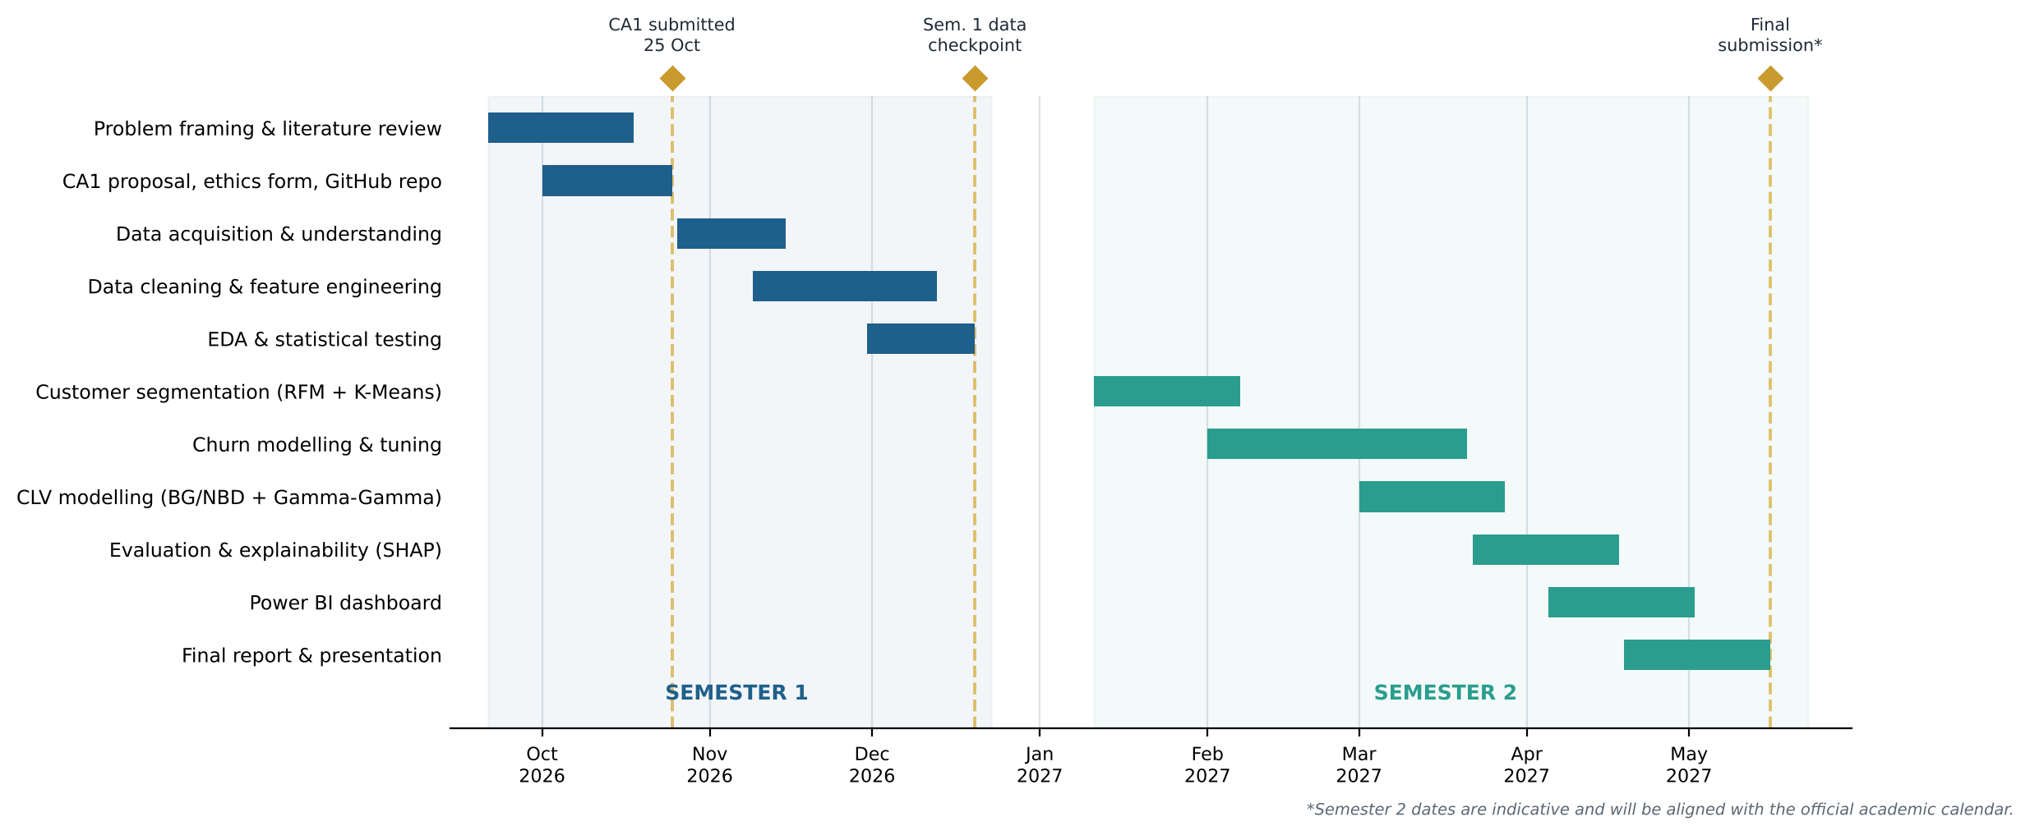
Figure 2. Project timeline (Gantt chart) across both semesters.

10. Ethical and Legal Considerations
Privacy and data protection. Customer IDs are pseudonymised numbers with no names, emails or addresses. Because pseudonymised data can still count as personal data under the GDPR, the project applies its principles of data minimisation and purpose limitation (European Parliament and Council of the European Union, 2016; Data Protection Act 2018): no attempt at re-identification and no linking with external data.
Licensing and security. The CC BY 4.0 licence is respected by crediting the creator. Raw data are not committed to GitHub; a script downloads them from UCI. The repository is shared only with the lecturer.
Fairness and vulnerable groups. The data describe business transactions and contain no protected characteristics, minors or human-subject interaction, in line with the signed CCT ethics form. Predictions will be used to offer retention incentives, never to deny service.
AI use. Claude was used as declared on the cover page and in Appendix A.

References
Anthropic (2026) Claude Opus 5.5 Available at: https://claude.ai (Accessed: 6 October 2026).
Breiman, L. (2001) ‘Random forests’, Machine Learning, 45(1), pp. 5–32.
Chapman, P., Clinton, J., Kerber, R., Khabaza, T., Reinartz, T., Shearer, C. and Wirth, R. (2000) CRISP-DM 1.0: Step-by-step data mining guide. SPSS Inc.
Chen, D. (2012) Online Retail II [Dataset]. UCI Machine Learning Repository. Available at: https://doi.org/10.24432/C5CG6D (Accessed: 6 October 2026).
Chen, D., Sain, S.L. and Guo, K. (2012) ‘Data mining for the online retail industry: A case study of RFM model-based customer segmentation using data mining’, Journal of Database Marketing & Customer Strategy Management, 19(3), pp. 197–208.
Chen, T. and Guestrin, C. (2016) ‘XGBoost: A scalable tree boosting system’, Proceedings of the 22nd ACM SIGKDD International Conference on Knowledge Discovery and Data Mining. San Francisco, 13–17 August, pp. 785–794.
Creative Commons (no date) Attribution 4.0 International (CC BY 4.0). Available at: https://creativecommons.org/licenses/by/4.0/ (Accessed: 6 October 2026).
Dakan, R., Feller, J. and Anthropic (2025) AI Fluency Framework. Available at: https://www.anthropic.com (Accessed: 6 October 2026).
Data Protection Act 2018 (No. 7 of 2018). Dublin: Stationery Office. Available at: https://www.irishstatutebook.ie (Accessed: 6 October 2026).
Davenport, T.H. and Harris, J.G. (2007) Competing on analytics: The new science of winning. Boston: Harvard Business School Press.
DeLong, E.R., DeLong, D.M. and Clarke-Pearson, D.L. (1988) ‘Comparing the areas under two or more correlated receiver operating characteristic curves: A nonparametric approach’, Biometrics, 44(3), pp. 837–845.
European Parliament and Council of the European Union (2016) Regulation (EU) 2016/679 (General Data Protection Regulation). Official Journal of the European Union, L 119, pp. 1–88.
Fader, P.S., Hardie, B.G.S. and Lee, K.L. (2005a) ‘“Counting your customers” the easy way: An alternative to the Pareto/NBD model’, Marketing Science, 24(2), pp. 275–284.
Fader, P.S., Hardie, B.G.S. and Lee, K.L. (2005b) ‘RFM and CLV: Using iso-value curves for customer base analysis’, Journal of Marketing Research, 42(4), pp. 415–430.
Lundberg, S.M. and Lee, S.-I. (2017) ‘A unified approach to interpreting model predictions’, Advances in Neural Information Processing Systems, 30, pp. 4765–4774.
Reichheld, F.F. and Sasser, W.E. (1990) ‘Zero defections: Quality comes to services’, Harvard Business Review, 68(5), pp. 105–111.
Verbeke, W., Dejaeger, K., Martens, D., Hur, J. and Baesens, B. (2012) ‘New insights into churn prediction in the telecommunication sector: A profit driven data mining approach’, European Journal of Operational Research, 218(1), pp. 211–229.

Appendix A: Use of AI

A.1 AI Declaration (AI Fluency Framework)
AI competence | Student response
Delegation | I used Claude (Anthropic) to interpret the assessment brief, suggest a structure for the proposal, run an initial profile of the Online Retail II dataset (size, missing values, duplicates, estimated churn rate) and draft the architecture and Gantt diagrams. I chose the dataset, the business problem and the final wording myself, and I did not use AI to write my final analysis without review.
Description | My prompts (A.2) stated the module, the brief and the documents provided. I refined them once to ask for a simpler explanation of what the project involves before drafting.
Discernment | I checked the dataset facts (size, missing customer, churn rate, revenue share, variables, dates and licence) by re-running the code on the dataset myself I checked each reference against the UCI repository page, confirmed every reference exists and matches its citation, and rewrote the text in my own words. I accepted the overall structure, modified and rejected.
Diligence | Tool used: Claude (Anthropic, 2026). I shared only the assessment brief, openly licensed dataset; no confidential data were entered. All external sources are referenced using Harvard style.

A.2 Prompts and outputs
Exact prompt:
Act as an academic specialist in Strategic Thinking, Business Analytics, and Data Science at undergraduate level.

I am preparing a Project Proposal for a Strategic Thinking module. Help me develop a structured academic draft for a project proposal concerning customer churn prediction and Customer Lifetime Value (CLV) estimation for an online retailer.

The proposed project will use the Online Retail II dataset from the UCI Machine Learning Repository.

Before drafting, review the assessment brief and any templates I provide. Follow their required structure, assessment criteria, academic conventions, word limits, and submission requirements. If any requirement is unclear or missing, identify it rather than inventing it.

Organise the proposal using the following sections, adapting them to the official assessment brief:

1. Project Title: Develop a concise title that communicates the business problem and proposed analytical solution.

2. Introduction: Explain the business context, the strategic importance of customer retention, and the potential role of data analytics in supporting business decisions.

3. Problem Definition: Define the business problem, explain why it matters, and identify the decisions that customer churn prediction and CLV estimation could support.

4. Aim and Objectives: Formulate one clear research aim, measurable objectives, and appropriate research hypotheses. Distinguish proposed targets from results that have not yet been measured.

5. Scope: Define what is included and excluded, including the dataset, customer population, analytical tasks, intended deliverables, and project limitations.

6. Methodology: Explain how CRISP-DM could structure the project. Assess the suitability of data cleaning, exploratory data analysis, RFM analysis, customer segmentation, classification algorithms, churn labelling, temporal validation, model evaluation, model explainability, and CLV estimation. Explain the rationale and limitations of each proposed method.

7. Data Sources: Describe the proposed dataset, its variables, coverage, quality limitations, source, and licence. Verify factual claims against the original UCI documentation where possible.

8. Expected Deliverables: Specify realistic outputs, such as reproducible notebooks, a documented dataset, model evaluation results, customer-retention recommendations, and a dashboard prototype, where appropriate.

9. Project Timeline: Propose a realistic timeline across the relevant academic semesters, showing key tasks, milestones, dependencies, and deliverables.

10. Ethical and Legal Considerations: Discuss relevant data protection, licensing, security, fairness, transparency, and responsible-use considerations. Distinguish confirmed legal requirements from general recommendations.

11. References: Suggest relevant academic literature and authoritative sources. Use the required referencing style if specified in the assessment brief. Never fabricate references, DOIs, quotations, authors, publication dates, or URLs. Clearly flag references that require verification.

12. Appendix and Visuals: Recommend appropriate supporting material, such as a CRISP-DM workflow diagram, a project timeline or Gantt chart, and an AI-use declaration if required by the institution. Explain what each visual should communicate.

For the methodology, critically assess whether a 90-day period without a purchase is an appropriate operational definition of churn in a non-contractual retail setting. Explain how the observation window and outcome window should be designed to prevent data leakage. Discuss the strengths and limitations of logistic regression, Random Forest, and XGBoost, and assess whether BG/NBD and Gamma-Gamma models are appropriate for estimating CLV given the characteristics of the data.

For model evaluation, consider appropriate metrics such as ROC-AUC, PR-AUC, recall, and business-oriented measures. Do not promise a particular model performance or business outcome without empirical evidence.

Writing requirements:
- Use clear, formal academic English suitable for an undergraduate proposal.
- Maintain a logical connection between the business problem, objectives, methods, evaluation, and expected deliverables.
- Provide sufficient detail for each section without unnecessary repetition.
- Distinguish established facts, assumptions, proposed methods, and expected outcomes.
- Identify unsupported claims, methodological risks, and areas requiring further research.
- Do not state that data cleaning, modelling, testing, or validation has been completed unless evidence is provided.
- Do not invent assessment requirements or claim compliance with institutional policies that have not been supplied.
- Use citations for claims that require academic or factual support.

First, explain briefly how the proposed project addresses the business problem. Then produce the structured draft. After the draft, provide a critical-review checklist identifying the decisions, factual claims, references, and methodological choices that I should verify and refine independently before submission.

Treat the result as a draft for review and learning, not as a verified final submission. Explain the reasoning behind important methodological recommendations so that I can understand, evaluate, and justify the choices in my own work.

Relevant output: A long draft proposal (12 sections) as a Claude document, including a churn observation/outcome window diagram, a draft timeline, a list of missing brief requirements, references marked "[verify]", and a critical-review checklist. The AI flagged that no assessment brief had been attached.

Prompt 2 – Aligning to the official brief
Exact prompt (with the file "CA1-Strategic Thinking- 20.docx" attached):
esa debe ser la estructura
Relevant output: A Word proposal restructured to the brief’s 10 sections and about 1,000 words: objectives reduced to five, one business hypothesis, Harvard references, a high-level architecture diagram and a Gantt chart covering both semesters. The AI listed remaining tasks (cover page, GitHub link, ethics form, AI declaration, reference verification).

Prompt 3 – Timeline adjustment
Exact prompt:
puede el timeline debe terminar en mayo
Relevant output: Gantt chart revised so that the timeline ends in May 2027.
